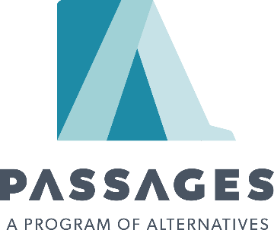
PARC Packing List
Welcome! When you arrived to Passages, your personal clothes will be locked in property for you. You will be provided with the following attire:
- Bras – two (2) sports bras. (Underwire bras are not allowed in the ADT facility. If you came in with one, it will be placed in your property.)
- Socks – seven (7) pairs.
- Shoes – one (1) pair of Crocks.
- Panties – seven (7) pairs.
- Nightgowns and bottoms – two (2).
- Exercise shirt and shorts—two (2).
- Passages shirts and bottoms—seven (7) of each.
- Hygiene kits are provided at no cost to the resident. This includes: comb, toothbrush, toothbrush cap, nail file, two hair ties, toothpaste, tweezers, body soap, face soap, bubble bath, water bottle, pads or tampons, and Chapstick.

You are allowed to keep the following personal property with you while you are at PARC:
- A wedding band/ring or wristwatch
- Eyeglasses/contacts
- Religious medallion/cross (if no larger than 2” by 2”)
- Up to two (2) religious items requiring special handling
- AA/NA Big Book, Daily Reflections or other AA/NA literature
- One (1) religious book
- One pair of closed toed shoes without laces
If you are prescribed medication, we ask that you come to PARC with your prescribed medication, in the originally prescribed medication bottles. If you have any additional questions about what to bring, please do not hesitate to reach out to Program Supervisor, Jen Porter. I am able to respond to email much quicker than phone messages.
1001 South 27th Street
Billings, MT 59101
406-294-960 ext287
jporter@altinc.net

